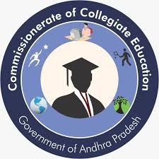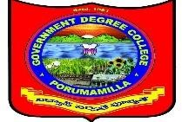**Govt. Degree College, Porumamilla**

**Dept. Of Commerce & Computer Applications**

**“International Accounting Day”**  On 10-11-2022

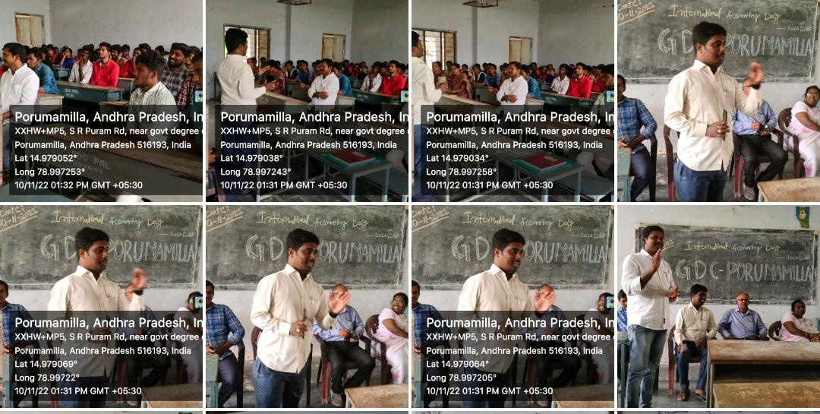

International accounting day celebrated by the Department of Commerce and Computer Applications on 10.11.2022. The principal Dr. N. Naresh Garu addressed the student’s importance of accounting and future of accounting. Head Dept. Of Commerce P Srinivasulu explain the importance of national and international accounting, other faculty Y. Eswaraiah spoke about duties of accounting and D. Narasaiah spoke to students have a better future who are having accounting knowledge. Vice principal S. Prakash rao sir, head dept. of English Dr. Sulochana madam, other faculty members and students involved in the programme.

